EAT ERASMUS Case Study Template
Case Study title:

Abstract (200 words)

What was your focus? What were your aims?
What was the context? (discipline/sample etc.) How did you investigate your focus?
What were your findings about what you did and what you learnt?
What implications are there for assessment and feedback practice and research in higher education?

Reporting on your case study
The aim of ERASMUS EAT is to look at how an integrated assessment framework (EAT) can support enhancements in assessment and feedback by trying to develop staff and student self-regulatory practices. Your case study will benefit from being very clearly focused from the outset and in considering how all the dimensions and sub-dimensions of the EAT Framework need to be attended to in order to address your core issue. Keeping it as simple as possible is a good thing. Engaging with student as much as possible and thinking clearly about the evidence that you would like to collect will help in the design and implementation of your idea.

Designing an Assessment Intervention: What is your assessment focus?
Prompts | Key questions
Focus | What is the key assessment issue you considered?
Why did you choose this focus? | Why did you focus on this? On the basis of what evidence? Why did it need looking at?
What was the context? Module / programme Discipline  Country  Who was involved – staff and students | What is the disciplinary/module/course context in which your assessment work is situated?
Why is this important?  What is your contribution  – is it original? Is it confirmatory of previous work? Is it actively taking the field forward by adding new understandings? | Why is what you did important?
How does this work contribute to current understandings we have  of assessment and feedback  To what extent are you aware of current national and international assessment and feedback higher education debates | How does what you focused on link to current understandings of and priorities in assessment and feedback within your institution and more widely in higher education?

Implementation: What did you do?
Prompts | Key questions
The project promotes an action research type approach – working with students and staff to implement ideas and then evaluating them.  It encourages the use of a mixed methodology and methods  – the use of quantitative methods (e.g. survey data) and qualitative approaches (e.g., discussions with colleagues) to investigate practice. | How did you investigate your focus?  Did you do any pre and post testing of ideas/abilities/ attitudes?  Were you able to draw on a variety of sources of information to support your findings?  Did you use EAT to measure student/staff engagement in assessment pre and post?
Describe what your approach involved.  What did you do to enhance a self-regulatory approach to assessment and feedback practice  What roles did students and educators play?  See Moore et al (2015) Process diagram to help you describe the elements of what you did? | What were the key things you did and with whom?  What student and staff groups did you engage with and how?  Who approved ethical consent? (Institution?)  Over what time scale did you conduct this project?  Did it involve 1 or several iterations of change initiatives?  What information did you collect?  What tools/resources did you use?
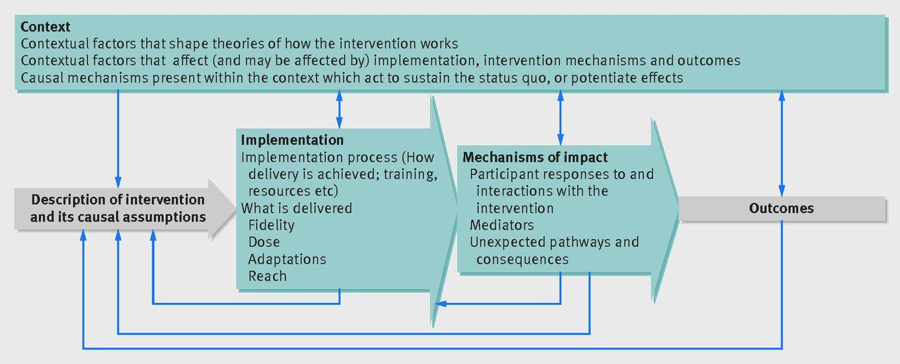

Figure 1: Moore, G. M., Audrey, S., Barker, M., Bond, L., Bonell, C., Hardeman, W., Moore, L., O’Cathain, A., Tinati, T., Wight, D., & Baird, J. (2015). Process evaluation of complex interventions: Medical Research Council Guidance. BMJ 2015; 3350:h1258

How was what you did aligned to the EAT concepts (FIDELITY) See check list below?  - Inclusive – do all students have equal access to learning and equal chances to do well?  - Shared beliefs and values –  have these been discussed and agreed between staff and students? Is there agreement on the key self-regulatory skills that need to be focused on?  - Student-staff partnership –  how genuine is this? To what extent are students encouraged to participate in all assessment decisions?  - Sensitive to context – how have you adapted assessment to suit your context? nuances of your discipline and course, situated within your faculty and institution; and nature of student intake – what is specific about your course/subject demands and types of students you have?  - Holistic – the whole experience of the student  - Integrative – how all aspects of assessment are interrelated and impact one another  - Agentic – allows students and lecturers to take control of their learning/teaching  - Engagement in meaningful learning experiences – relevant  - Sustainable – means manageable for all; also enabling students to manage their own learning. fthemselves  – so extent to which they are able to accurately assess the quality of their own work. | How did you incorporate EAT concepts into your design?  How did you support colleagues to understand how to apply these concepts?  Were staff able to engage students in co-design? (see Appendix F)
See Assessment and Feedback Principles Appendix A and  Student Engagement in Assessment templates | To what extent were you able to implement the EAT assessment and feedback principles?  What barriers and facilitators were there to implementation?

Assessing the Impact of your Intervention: Key findings

Prompts | Key questions
Did it engage the students and staff you wanted it to? | To what extent did your intervention reach your intended audience of staff and students?  Was it manageable?  Are there plans to test it more widely?
Note any reported impacts on students:  Did those who did engage do better than those who did not?  Did it narrow gaps in attainment between more and less advantaged students?  Student beliefs about their role in assessment  Student confidence  Student learning outcomes  Student engagement in assessment  Student satisfaction  Assessment Literacy  Ability to use, seek and give feedback  Contribution to assessment resources and valuable outputs | What were the impacts on students?  Did all students benefit equally?  What specific changes resulted if any?  Any unexpected outcomes?
Impact on staff engagement in training  Did it impact staff conceptions of assessment and the role of students in the process?  Did it make assessment more efficient?  Staff competency  Staff confidence  Staff collaboration  Staff assessment literacy  Better assessment design?  Did it lead to better curriculum design | What were the impacts on staff? Do staff have a better understanding of assessment?  Was assessment design improved as a consequence of what you did?
Are changes embedded within curriculum? Any longer term gains?  Development of effective assessment networks  Changes in attitudes?  Upskilling of staff  More efficient use of resource  Impacts on policy? | Sustainability: any longer term gains from the project? Has what you implemented become part of business as usual – will it be maintained?
What personal learning do you take away from the project?  (Use reflective templates to support evaluative activities) | What was the impact on those colleagues and students leading the case studies?  What were the key learning points for you?  What would you have done differently in retrospect?  How could you improve your design?
What are the key messages that would be useful for others trying to do this? | Transferability  Were there any subject specific findings that have relevance to the sector?  How can learning be adapted and utilized elsewhere?  What are the key messages/learning from this work

SUPPORTING DOCUMENTS

Key training elements before you start

- WHAT IS THE EAT FRAMEWORK: How Eat works: deciphering the EAT wheel / web.
- Concepts and principles underpinning the EAT Framework and why they are important
- Planning an Intervention: Establishing your Focus: Exploring your own practice and starting points within your own institutional context: What are the facilitators and barriers impacting assessment?
- Implementing Interventions – Key considerations and approaches to data collection and analysis.
- Analysing Impact and Effectiveness

APPENDIX A

Effective Assessment Feedback
The key aim of assessment feedback should be to support students to become more self-regulatory in managing their own learning as part of sustainable assessment practice; a focus on three core areas is recommended: Assessment Literacy; Facilitating Improvements in Learning; Holistic Assessment Design.

To support assessment literacy we should:
- Clarify what the assessment is and how it is organised. Explain the principles underpinning the design of assessment so that students can understand the relevance and value of it.
- Provide explicit guidance to students on the requirements of each assessment (e.g. clarification of assessment criteria; learning outcomes; good academic practice).
- Clarify with students the different forms, sources, and timings of feedback available including e-learning opportunities.
- Clarify the role of the student in the feedback process as an active participant (seeking, using, and giving feedback to self and peers; developing networks of support), and not just as a receiver of feedback.
- Provide opportunities for students to work with assessment criteria and to work with examples of work at different grade levels in order to understand ‘what constitutes good.’

To facilitate improvements in learning we should:
- Ensure that the curriculum design enables sufficient time for students to apply the lessons learnt from formative feedback in their summative assessments.
- Give clear and focused feedback on how students can improve their work including signposting the most important areas to address (what was good; what could be improved; and most importantly, how to improve).
- Ensure that formative feedback precedes summative assessment; that the links between formative feedback and the requirements of summative assessment are clear.
- Ensure that there are opportunities and support for students to develop self- assessment/self- monitoring skills, and training in peer feedback to support self-understanding of assessment and feedback.
- Ensure training opportunities on assessment feedback for all those engaged in curriculum delivery to enhance shared understanding of assessment requirements.

To promote holistic assessment design we should:
- Ensure that opportunities for formative assessment are integral to curriculum design at module and programme levels.
- Ensure that all core* resources are available to students electronically through the virtual learning environment (e.g. Blackboard) and other relevant sources from the start of the semester to enable students to take responsibility for organising their own learning.
- Provide an appropriate range and choice of assessment opportunities throughout a programme of study.
- Ensure that there are opportunities for students to feedback on learning and teaching, both individually, and via Student Groups (e.g., student union/representatives) during a taught course and at the end of it, to enable reasonable amendments to be made during the teaching of the course subject to the discretion of the course leader.
* Core = handbook; assessment guidelines; formative & summative tasks and deadlines; resources for each session (Based on: Evans, 2013
Appendix F: Developing Student Engagement in Assessment
Evans (2018) Transformative approaches to assessment practices using the EAT Framework in Balloo et al. 2018.

Transactional | Identify your position |  |  |  |  | Transformational
Assessment Literacy | 1 | 2 | 3 | 4 | 5
Telling - one directional guidance on assessment criteria - lecturer to student. |  |  |  |  |  | Explaining / discussing requirements with students.
Teacher driven rubrics. |  |  |  |  |  | Student generated rubrics.
Provision of exemplars. |  |  |  |  |  | Student development of exemplars.
Provision of assessment criteria. |  |  |  |  |  | Student creating assessment criteria.
Provision of glossaries. |  |  |  |  |  | Student generated glossaries.
Given assessment regulations. |  |  |  |  |  | Students contributing to development of regulations.
Assessment Feedback | 1 | 2 | 3 | 4 | 5 | Transformational
Reliance on the teacher for feedback. |  |  |  |  |  | Reliance on range of sources – emphasis on developing student self-assessment.
Corrective feedback – one directional from teacher to student – work corrected. |  |  |  |  |  | Examples of how to correct with the responsibility on the student to apply the approach.
Provision of guidance on how to improve. |  |  |  |  |  | Student responsibility for developing action plan based on feedback on how to improve.
Asks students to reflect on their feedback. |  |  |  |  |  | Provides frameworks to support students in reflection involving dialogic practices and focused application to demonstrate understanding rather than reflection alone.
Directive. Solutions provided. |  |  |  |  |  | Challenges the student to find solutions.
Focus on the immediate requirements of the module task |  |  |  |  |  | Focus on application of learning within and beyond the course.
Assessment Design | 1 | 2 | 3 | 4 | 5 | Transformational
Assessment tasks designed for students. |  |  |  |  |  | Assessment tasks designed with & by students.
Teacher summative assessment. |  |  |  |  |  | Student and teacher summative assessment.
Teacher ownership of assessment tasks. |  |  |  |  |  | Student ownership of assessment tasks.
Tasks designed exclusively to meet specific learning outcomes. |  |  |  |  |  | Tasks designed to meet learning outcomes and to go beyond.
Strongly scaffolded learning tasks- students regulated and told what to do. |  |  |  |  |  | Students taught to self-regulate as part of course design.
Resources to support learning provided but relationship between them not made explicit. |  |  |  |  |  | All key resources available from the outset to enable student control of learning & signposted in relation to tasks and key crunch points. Clear links to resources provided.
Guidance mainly provided by teacher. |  |  |  |  |  | Students supported to build networks and to identify guidance from range of sources.
Resources provided for students. |  |  |  |  |  | Students/teachers generate resources.
Limited opportunities for self-assessment. |  |  |  |  |  | Ongoing aligned opportunities for self-assessment from start to finish.
Limited opportunities to explore assessment holistically and to explore potential issues. Teacher directs solution-finding. |  |  |  |  |  | Key threshold concepts identified from the outset. Students encouraged to provide resources to support understanding in areas seen as difficult, and to find own solutions.

Appendix F Description

This Appendix asks you to consider how you engage with students as partners along a continuum from left to right of the table, moving from a directional/telling approach to a more transformative approach that engages students actively in the design of learning and teaching. In supporting the learning progression of students there may be times where a directive approach is the most suitable such as at key transition points into learning. However, if we are to promote student agency in learning, we need to actively engage them in taking a lead in their own learning.

Key to supporting student progression in learning is how and when we remove scaffolding of learning to support their engagement with and ownership of learning and teaching.

This resource can be used:
- as a self-reflection tool to evaluate your own practice

- to discuss teaching approaches with colleagues as an integral part of curriculum design to view key progression points in the student learning process and what approaches are best and where and when; to ensure a consistent approach to engaging students within the curriculum

- shared with students to emphasize the importance of their role within learning and to clarify your expectations of them as partners within learning and teaching

Sources

Evans, C. (2016). Enhancing assessment feedback practice in higher education: The EAT Framework. Available via : https://app.secure.griffith.edu.au/exlnt/entry/9549/view

Balloo, K., Evans, C., Hughes, A., Zhu, X., & Winstone, N. (2018). Explicit Assessment Criteria as the Antithesis of ‘Spoon-Feeding’: How transparency in the assessment process can support students’ self-regulatory development. Frontiers in Education

Moore, G. M., Audrey, S., Barker, M., Bond, L., Bonell, C., Hardeman, W., Moore, L., O’Cathain, A., Tinati, T., Wight, D., & Baird, J. (2015). Process evaluation of complex interventions: Medical Research Council Guidance. BMJ 2015; 3350:h1258

Useful Resources: Impacts on different Stakeholders

Understanding Pedagogy - Waring and Evans

https://www.routledge.com/Understanding-Pedagogy-Developing-a-critical-approach-to-teaching- and-learning/Waring-Evans/p/book/9780415571746

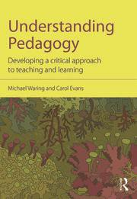
Understanding Pedagogy: Developing a critical approach to teaching and - Routledge & CRC Press
What is meant by pedagogy? How does our conception of pedagogy inform good teaching and learning? Pedagogy is a complex concept of which student and practising teachers need to have an understanding, yet there remain many ambiguities about what the term means, and how it informs learning in the classroom. Understanding Pedagogy examines pedagogy in a holistic way, supporting a more critical ...
www.routledge.com
Website: https://www.eatframework.com/eat-framework-

The PDFS can be downloaded from: https://www.eatframework.com/eat-framework

The pdf Accessible Version https://www.researchgate.net/publication/343933632_2020_online_EAT_DOC_AW_accessible_3

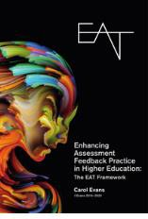
Extended
version https://www.researchgate.net/publication/343933483_EAT_Integrated_Assessment_ Evans_2020_Griffth_word_version

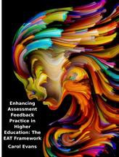

Abridged
version : https://www.researchgate.net/publication/350324719_EAT_Abridged_2020

